mathieu ndong
man333@drexel.edu

The Value of Strategic Insights in Business Analytics: A Detailed Analysis Using Time Series Modeling
US Employment: The Private Service Providing Sector
Abstract
In this paper we will explore key elements related to assumption clarification and framework setup in business analytics, particularly through the lens of time series modeling. The essay indeed focuses on the application of time series modeling techniques on the US employment data in the private service providing sector using the fpp2 library in the software R. While we will derive strategic insights based on both techniques used and outputs, we will cover important steps needed for assumption clarification and framework setup that guide business analytics. These steps include the verification of data validity, the necessity of data transformation, testing for stationarity, selecting appropriate models, and using these models for reliable forecasting. These elements collectively form a part of the broader framework for conducting business analytics effectively to accurately provide business insights to management.

Introduction
In an era where data drives decisions, the ability to extract strategic insights from business analytics is paramount. Companies must leverage data not just for operational efficiency but also for strategic planning and competitive advantage. This essay explores the immense value of strategic insights gained through time series modeling, using the U.S. employment data for the "Private Service-Providing" sector as a study example. By employing various analytical techniques such as STL decomposition, data transformation, stationarity testing and ARIMA modeling, we illustrate how these methods can inform strategic business decisions.
Understanding Trend and Seasonality through STL Decomposition
First, STL (Seasonal-Trend decomposition using Loess) decomposition is a robust method for analyzing time series data. It decomposes a series into three main components: trend, seasonal, and residual. This method helps to uncover underlying patterns that are not immediately visible in the raw data. We applied STL decomposition to the "Private Service-Providing" sector employment data as shown in Fig.1.
By decomposing the data, we can identify both the long-term trend and seasonal patterns. This analysis reveals that the employment in this sector shows distinct seasonal variations and a noticeable upward trend over time. Understanding these patterns is critical for strategic planning. For instance, if a company knows that employment typically increases in certain months of the year, it can prepare for higher demand for labor and adjust its recruitment and training programs accordingly.
Identifying the Need for Data Transformation and Stationarity
As a business analyst you must first verify the validity of the data. With this dataset, the data are indeed valid and issued from the Federal Reserve of Economic Data. However, data transformation is often necessary to stabilize the variance and make the series more suitable for modeling. Logarithmic transformation is one of such methods that can help in achieving a more consistent variance across the series, which is crucial for accurate modeling and forecasting.
Applying a logarithmic transformation helps to normalize the data, making patterns more discernible and models more robust as shown in Fig.2. This step is strategically significant as it enhances the quality of the insights derived from the data. For example, a more stable variance allows for better identification of trends and seasonal effects, leading to more accurate forecasts and better decision-making as the data is now considered stationarity. Passing a stationary test is fundamental for many time series models such as ours. Now that we know that we have a constant mean and variance over time, we can consequently select the adequate ARIMA models.
Selecting Appropriate ARIMA Models
ARIMA (AutoRegressive Integrated Moving Average) models are widely used for forecasting time series data due to their flexibility in capturing different temporal structures. We explored several ARIMA models to identify the best fit based on AICc. The model with the lowest AIC is the best one as shown in (Fig.3&4).
The stepwise and automatic ARIMA models, which suggest an ARIMA (2,1,2) structure, are found to be the best. This model selection process is strategic as it ensures the most accurate and efficient model is used for forecasting. The ability to choose the best model based on statistical criteria ensures that the forecasts are as reliable as possible, providing valuable insights for strategic planning.
Forecasting and Evaluating Predictions
Finally, forecasting future values is one of the most valuable applications of time series analysis. Accurate forecasts provide strategic insights into decision-making. We forecast the next three years of employment data for the "Private Service-Providing" sector starting in 2017and compare it to actual data to evaluate their accuracy (Fig. 5). The values were highly similar across that 3-year span. It should be noted that our forecast would have been wrong because of the pandemic on US employment starting in March 2020. Therefore, strategic decision cannot always relied on data analytics insights as certain events are unpredictable.
Conclusion
The detailed analysis of the U.S. employment data for the "Private Service-Providing" sector demonstrates the immense value of strategic insights derived from business analytics. By employing STL decomposition, data transformation and ARIMA modeling. We gain actionable insights that guide strategic decision-making. These techniques reveal underlying patterns and ensure reliable forecasts, enabling businesses to make informed decisions and plan effectively. In a competitive and ever-changing business environment, the ability to leverage data-driven strategies is crucial for achieving sustainable growth and maintaining a competitive edge. This case study exemplifies how strategic insights from business analytics can empower organizations in the “private service providing” to navigate uncertainties, optimize operations, and achieve long-term success.

Exhibit
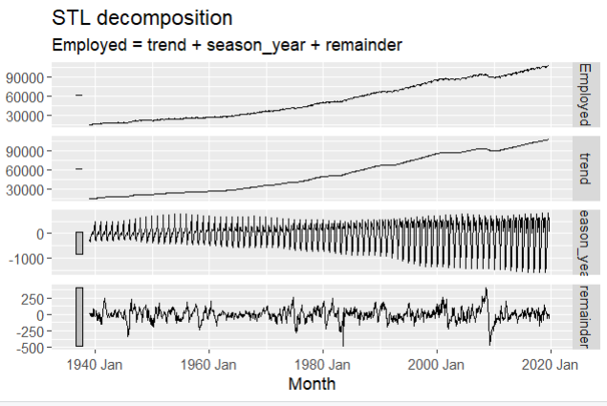

Figure 1
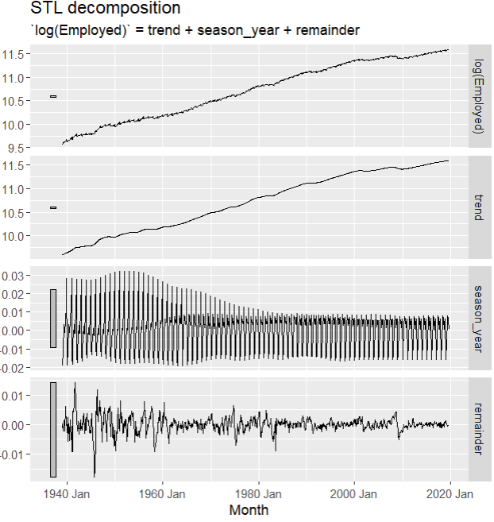
Figure 2
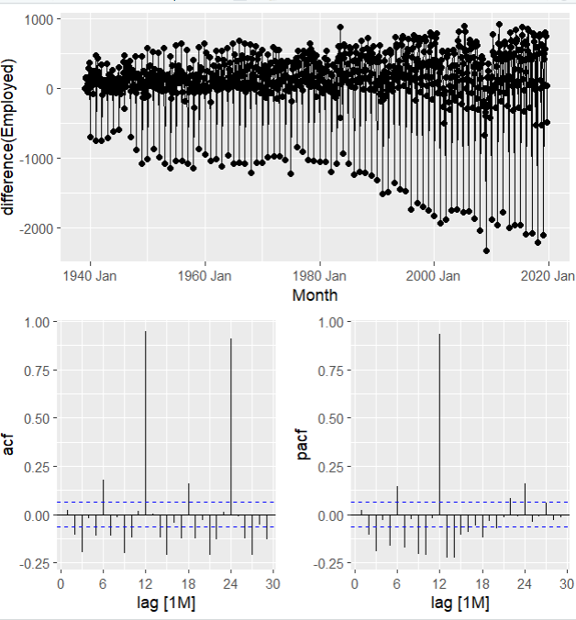
Figure 3
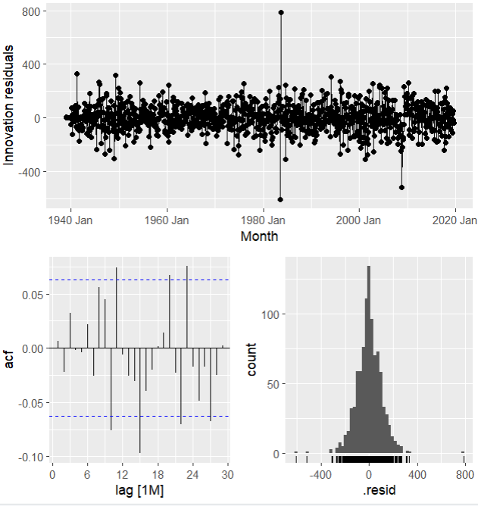
Figure 4

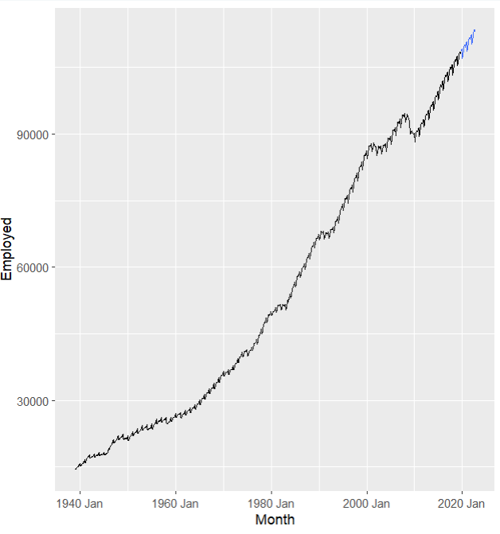
Forecast (best model)
Figure 5

